**ASSIGNMENT-1**

**FULL STACK DEVELOPMENT(MERN STACK)**

**Name : B. Vinod Kumar Reddy**

**G-mail : beedalavinod@gmail.com**

**Hallticket : 209F1A0502**

**Course : Full Stack Devlopment(MERN stack).**

**College :Sri Venkateswara Institute of Technology,Anantapur.**

<!DOCTYPE html>

<html>

<head>

<title>Landing page</title>

<meta charset="utf-8">

<meta name="viewport"content="width=device-width,initial-scale=1.0">

<link rel="stylesheet" href="style.css">

<script type="module" src="https://unpkg.com/ionicons@7.1.0/dist/ionicons/ionicons.esm.js"></script>

</head>

<body>

<div class="container">

<div class="row">

<nav class="navbar">

<h1></h1>

<ul>

<li><a href="#section2"><b>Home</b></a></li>

<li><a href="#section1"><b>About</b></a></li>

<li><a href="#section3"><b>Places</b></a></li>

</ul>

</nav>

<div class="content" id="section2">

<h1><b>Travel</b></h1>

<p> <b>Embark on a journey of a lifetime and explore the <p>world's most breathtaking destinations with our expert travel advice.</p>

<p>From exotic beaches to cultural wonders, we've got you covered with our comprehensive travel guides and insider tips.</p></b> </p>

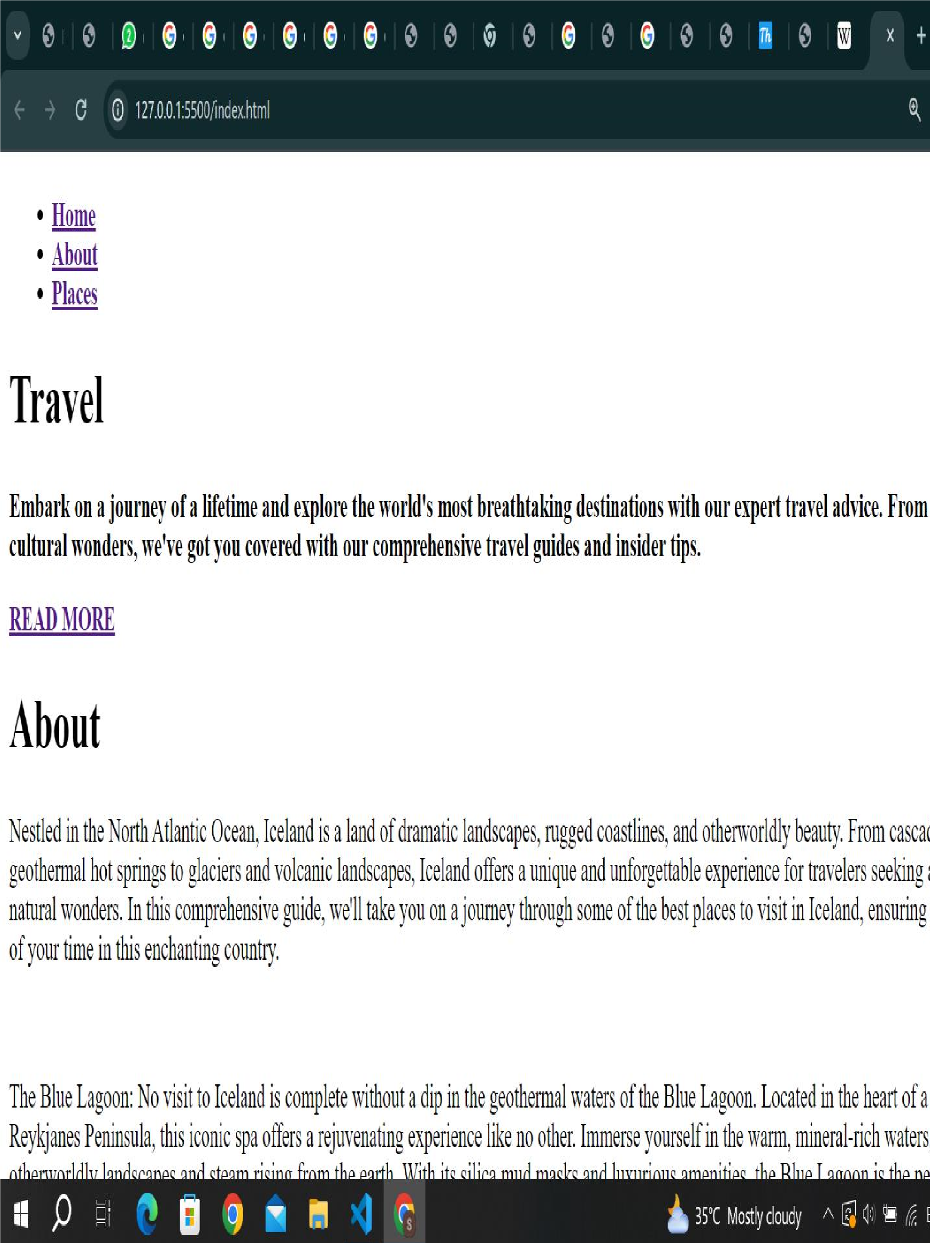

<a href="#section1"><b>READ MORE</b></a>

</div>

</div>

</div>

<div class="image" id="section1">

<h1>About</h1>

<p>Nestled in the North Atlantic Ocean, Iceland is a land of dramatic landscapes, rugged coastlines, and otherworldly beauty. From cascading waterfalls and geothermal hot springs to glaciers and volcanic landscapes, Iceland offers a unique and unforgettable experience for travelers seeking adventure and natural wonders. In this comprehensive guide, we'll take you on a journey through some of the best places to visit in Iceland, ensuring you make the most of your time in this enchanting country. </p><br>

<p>The Blue Lagoon: No visit to Iceland is complete without a dip in the geothermal waters of the Blue Lagoon. Located in the heart of a lava field on the Reykjanes Peninsula, this iconic spa offers a rejuvenating experience like no other. Immerse yourself in the warm, mineral-rich waters, surrounded by otherworldly landscapes and steam rising from the earth. With its silica mud masks and luxurious amenities, the Blue Lagoon is the perfect place to unwind and relax after a day of exploration</p><br>

<p>Gullfoss Waterfall: Witness the raw power and beauty of Gullfoss, one of Iceland's most iconic waterfalls. Tumbling in two majestic tiers into a narrow canyon, Gullfoss is a sight to behold in any season. Marvel at the sheer volume of water thundering over the edge, feel the mist on your face, and snap photos of rainbows dancing in the spray. Located along the Golden Circle route, Gullfoss is easily accessible from Reykjavik and makes for a breathtaking day trip.</p>

<div class="courses"id="section3">

<h1>Places</h1>

<ul>

<li>Munnar,Kerela</li>

<li>Pondicherry,Kerela</li>

<li>Ooty,Tamil Nadu</li>

<li>Taj Mahal,Agra</li>

<li>Goa, Goa</li>

<li>Delhi</li>

<li>Kolkata</li>

</ul>

</div>

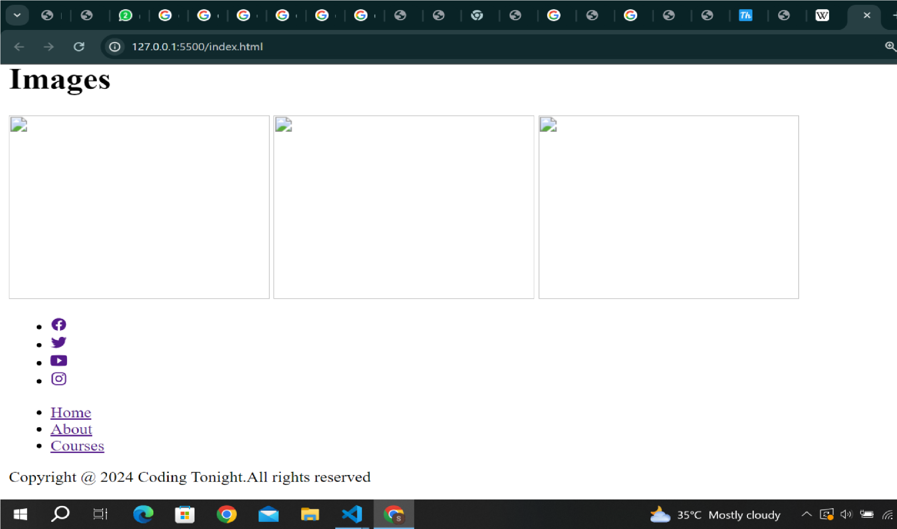

|  |
| --- |
| *{ margin: 0px; padding: 0px; box-sizing: border-box; font-family: "Poppins", sans-serif;  }  .container{ width: 100%; min-height: 100vh;    background-position: center; background-size: cover; background-image: url(https://media.istockphoto.com/id/904172104/photo/weve-made-it-all-this-way-i-amproud.jpg?s=612x612&w=0&k=20&c=MewnsAhbeGRcMBN9_ZKhThmqPK6c8nCT8XYk5ZM_hdg=) } .row{ width: 100%; padding: 0px 80px;    } |

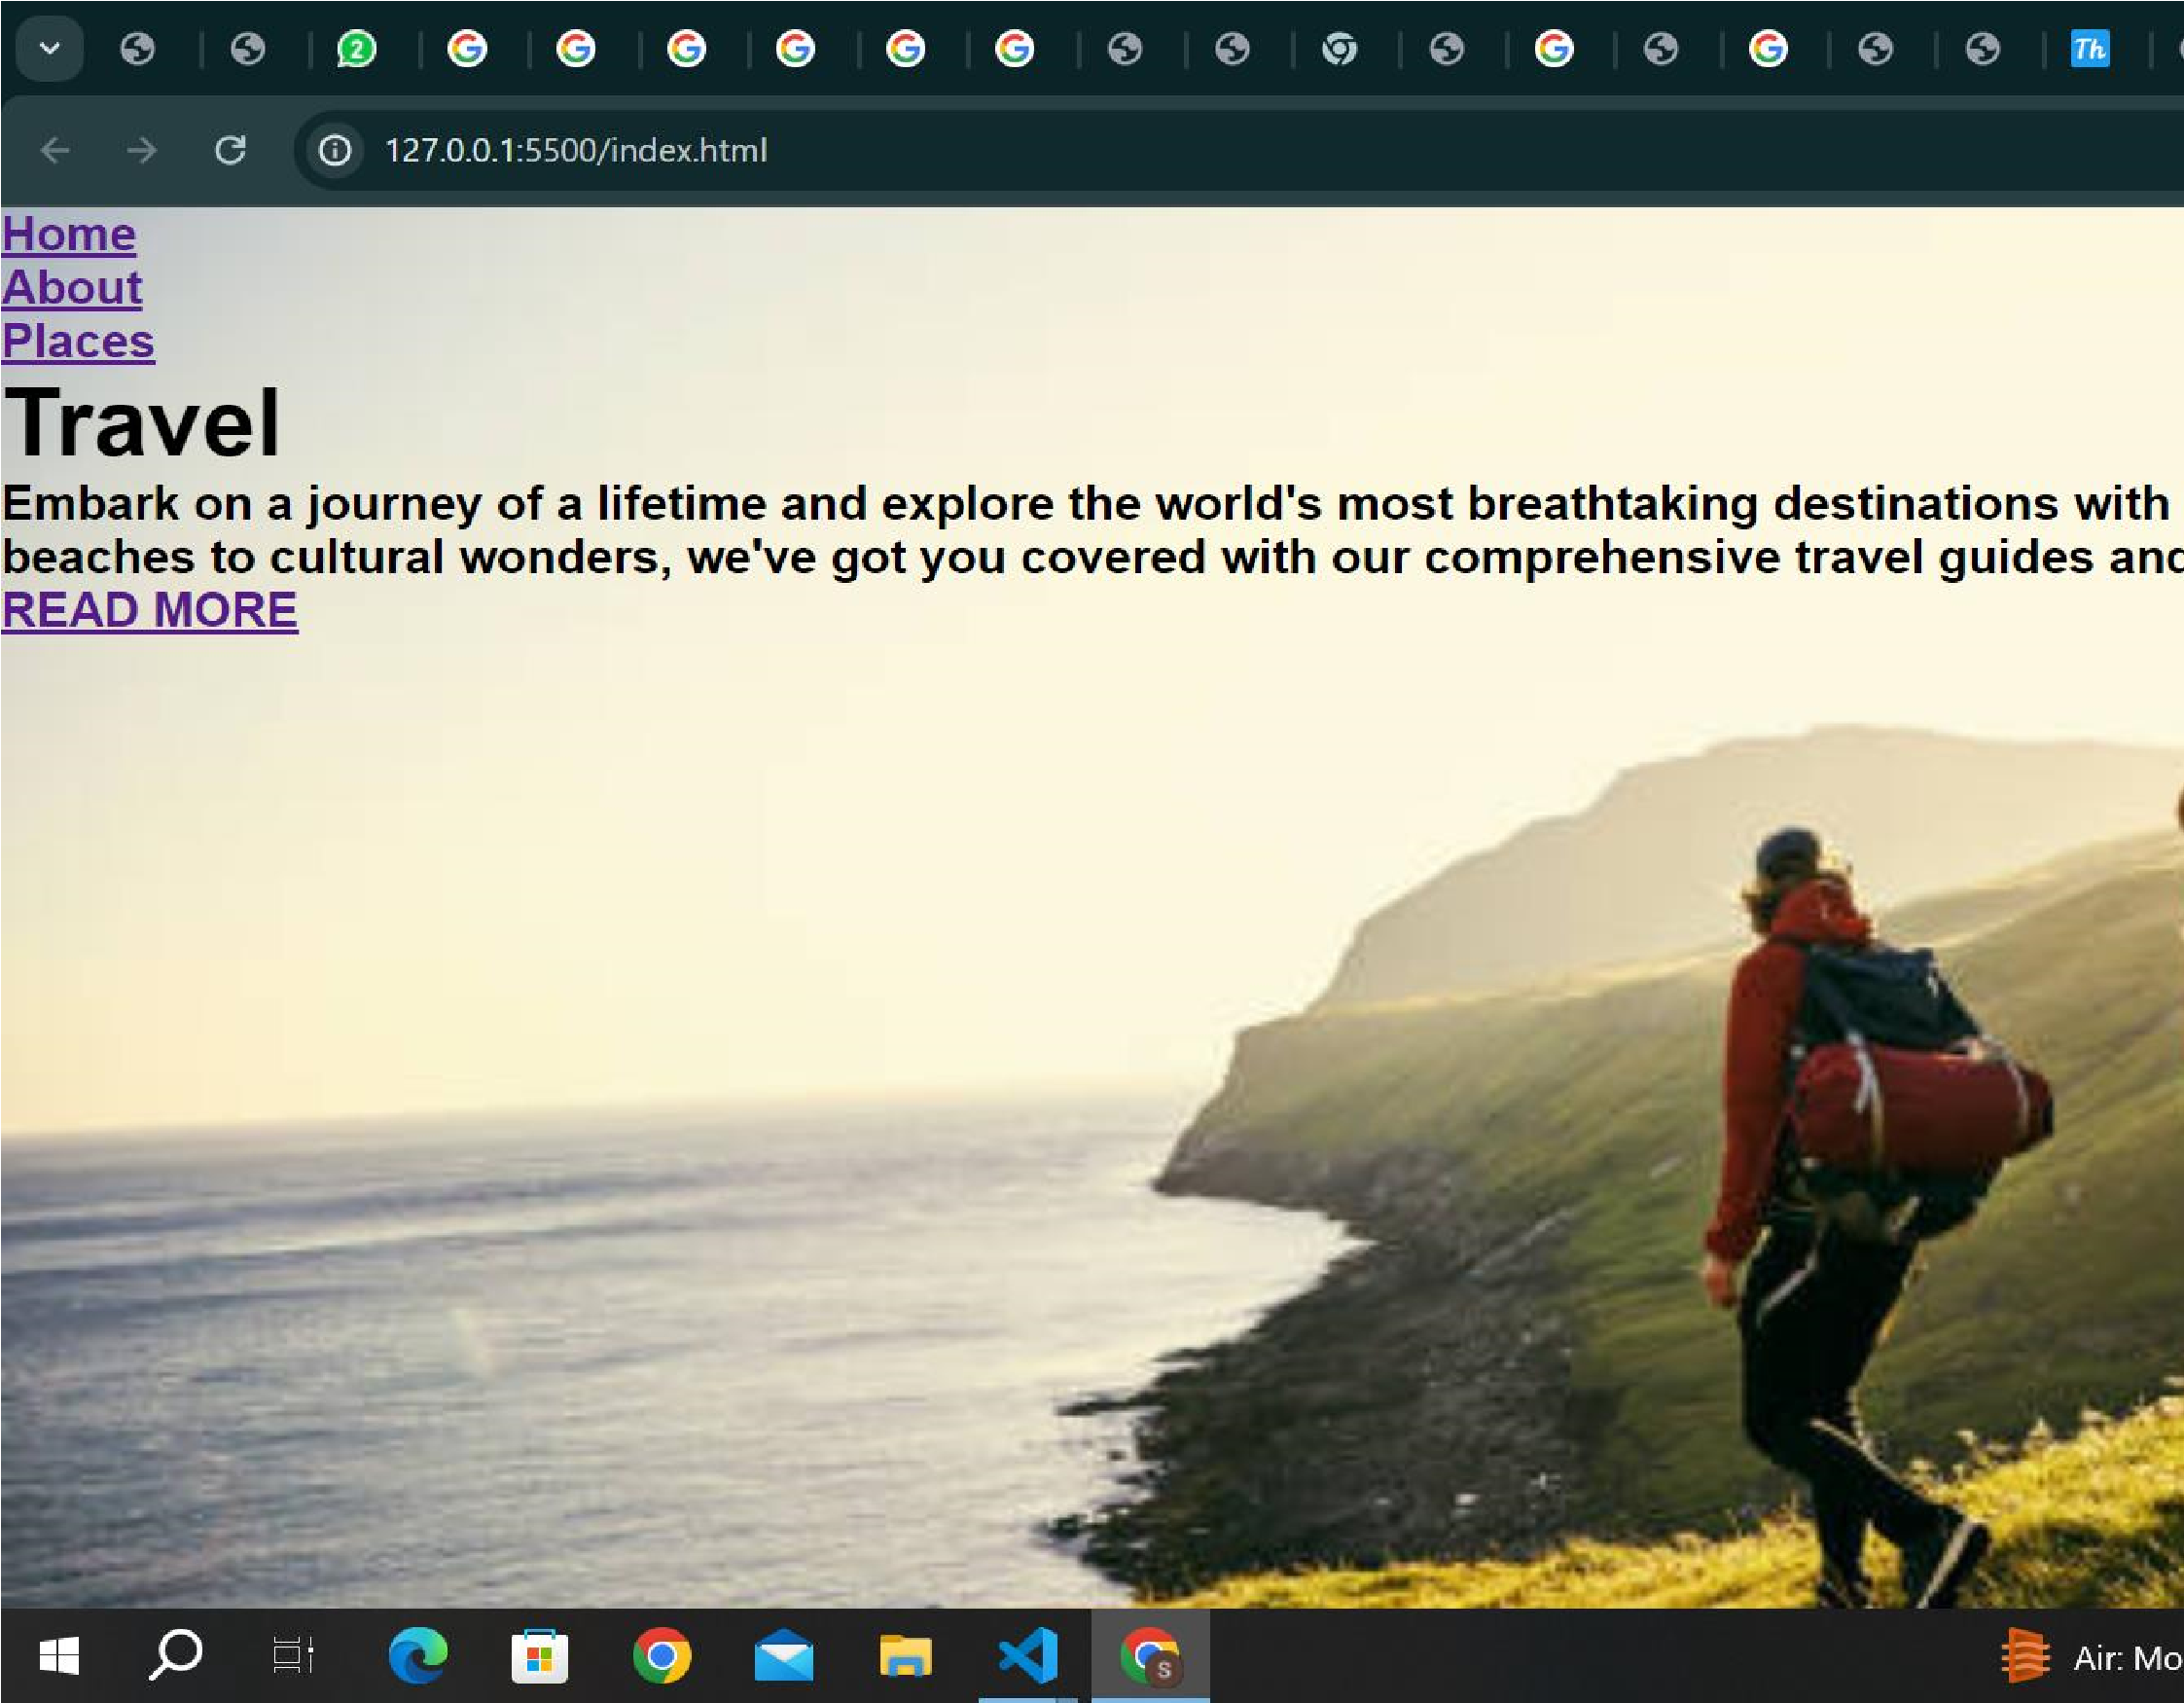

|  |
| --- |
| .navbar{ width: 100%; display: flex; justify-content: space-between; align-items: center; padding: 10px 0px; z-index: 1;  }  .navbar ul{ display: flex; justify-content: center; align-items: center; margin-top: 20px;  }  .navbar ul li{ list-style: none;  } |

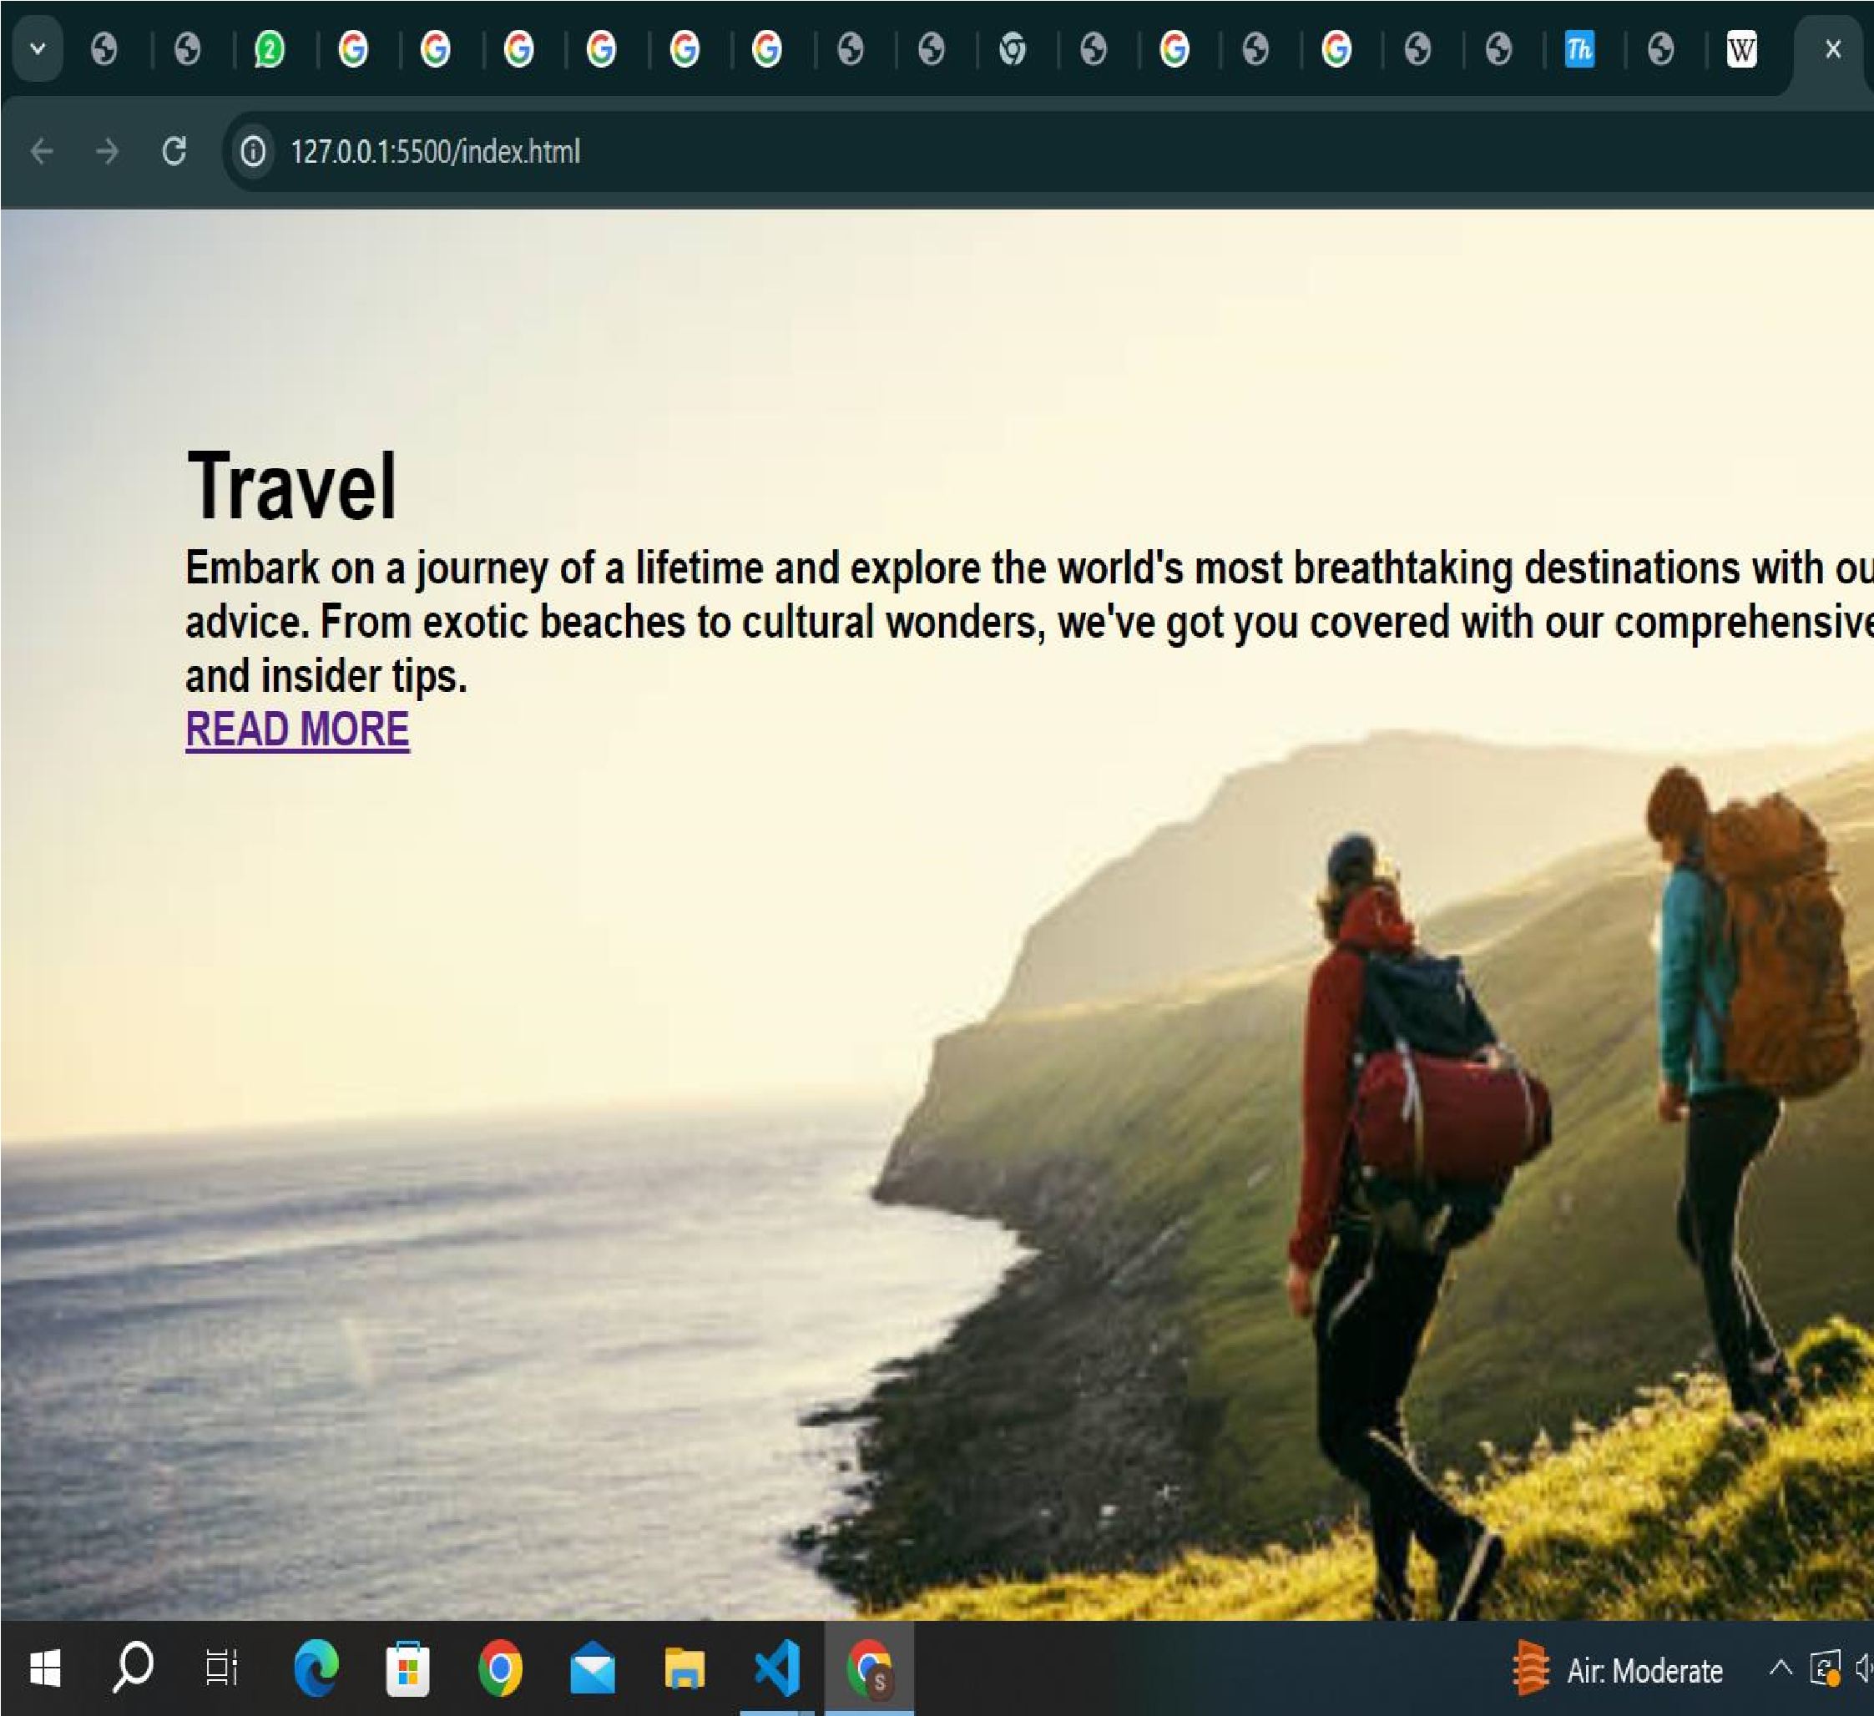

|  |
| --- |
| .content{ width: 100%; margin-top: 200px; color: aliceblue; position: absolute; top: 0; left: 0; display: flex;  justify-content: left;    flex-direction: column;  }  .content h1{ font-size: 40px; font-family:cursive; |

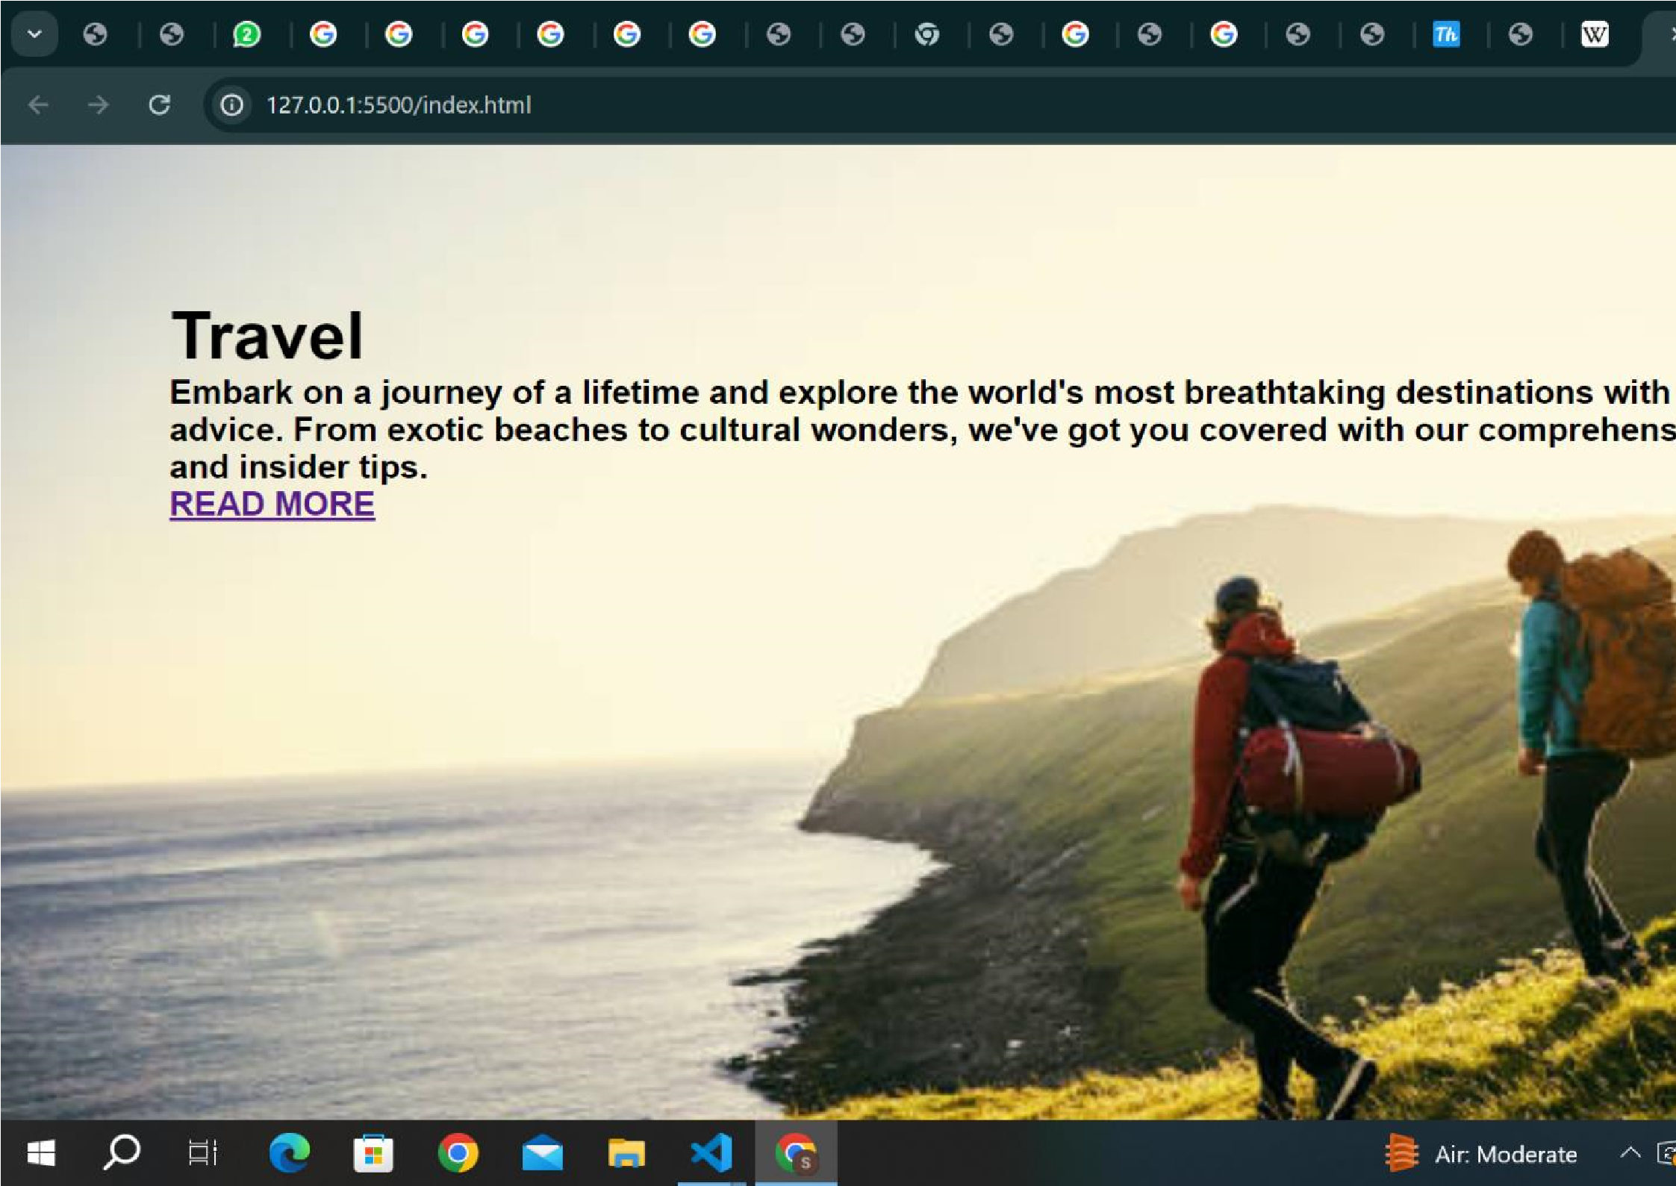 text-transform: uppercase; color:black;

}

|  |
| --- |
| .content p{ font-size: 15px; color:aqua; font-weight: 30px; font-family: cursive;  }  .content a{ font-size: 20px; margin-top: 20px; text-decoration: none;    display: inline-block; letter-spacing: 1.5px; padding: 10px 10px; border-radius: 5px; color: rgb(93, 59, 215); } |

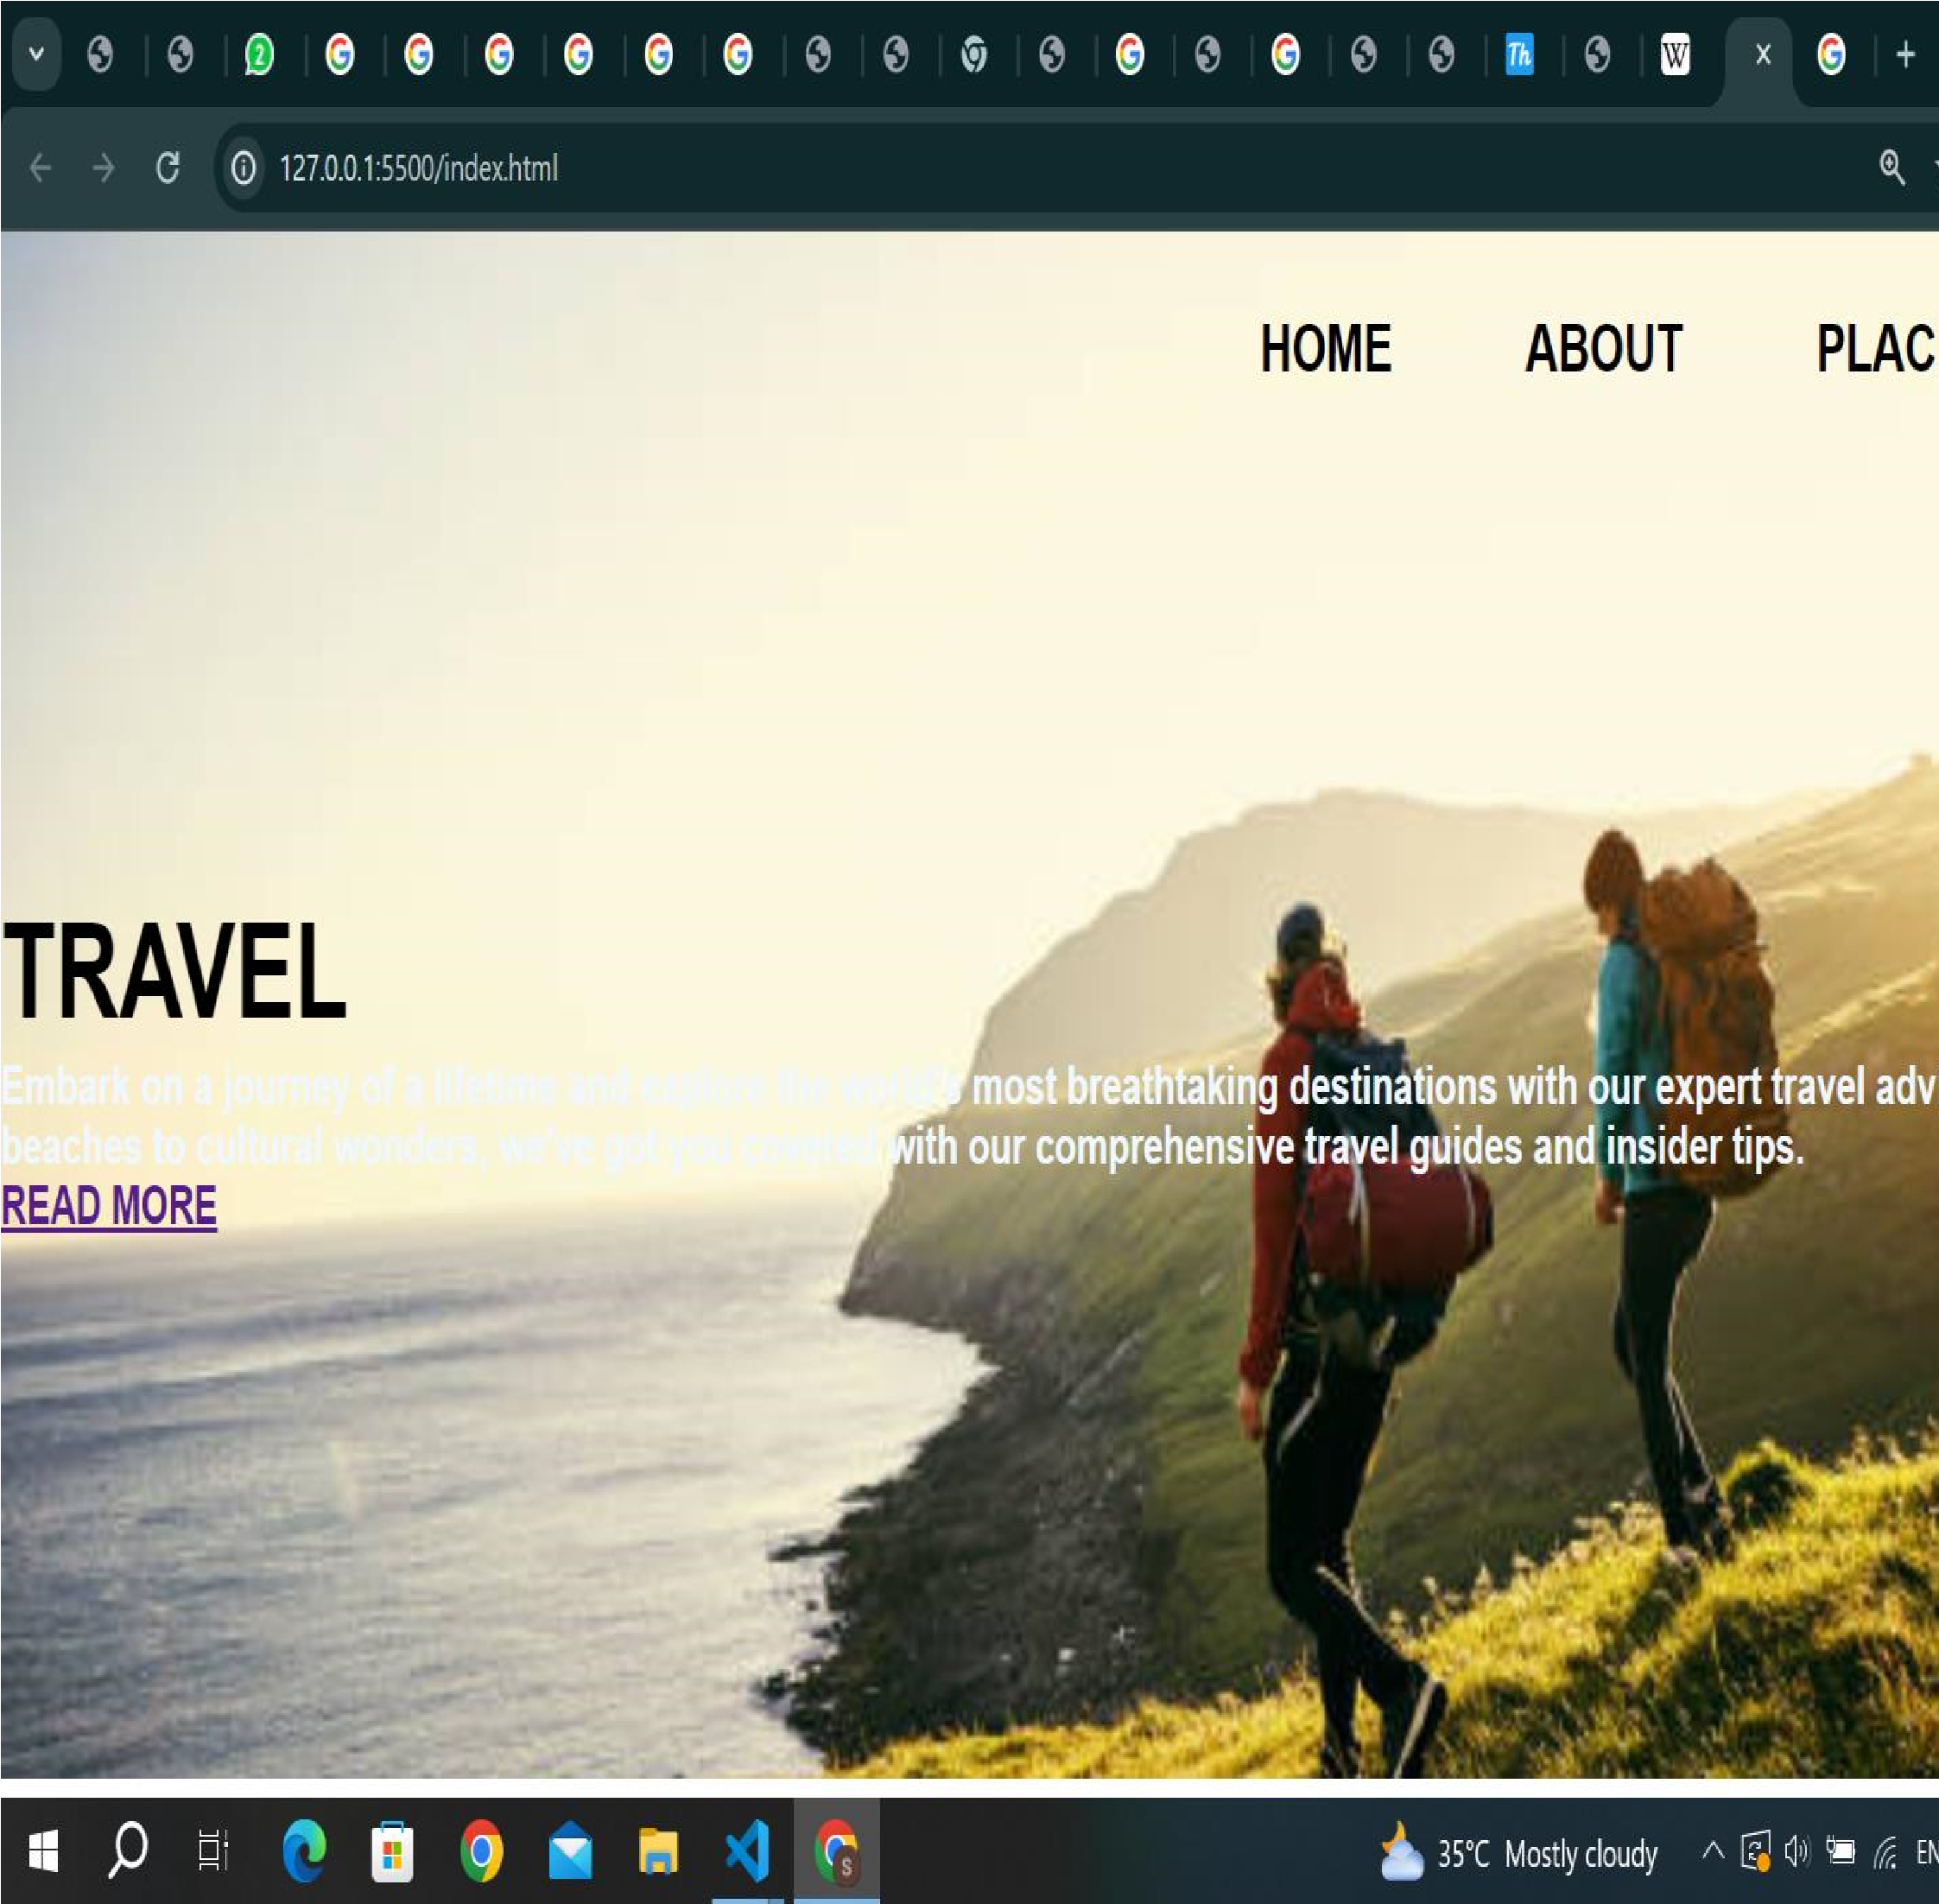

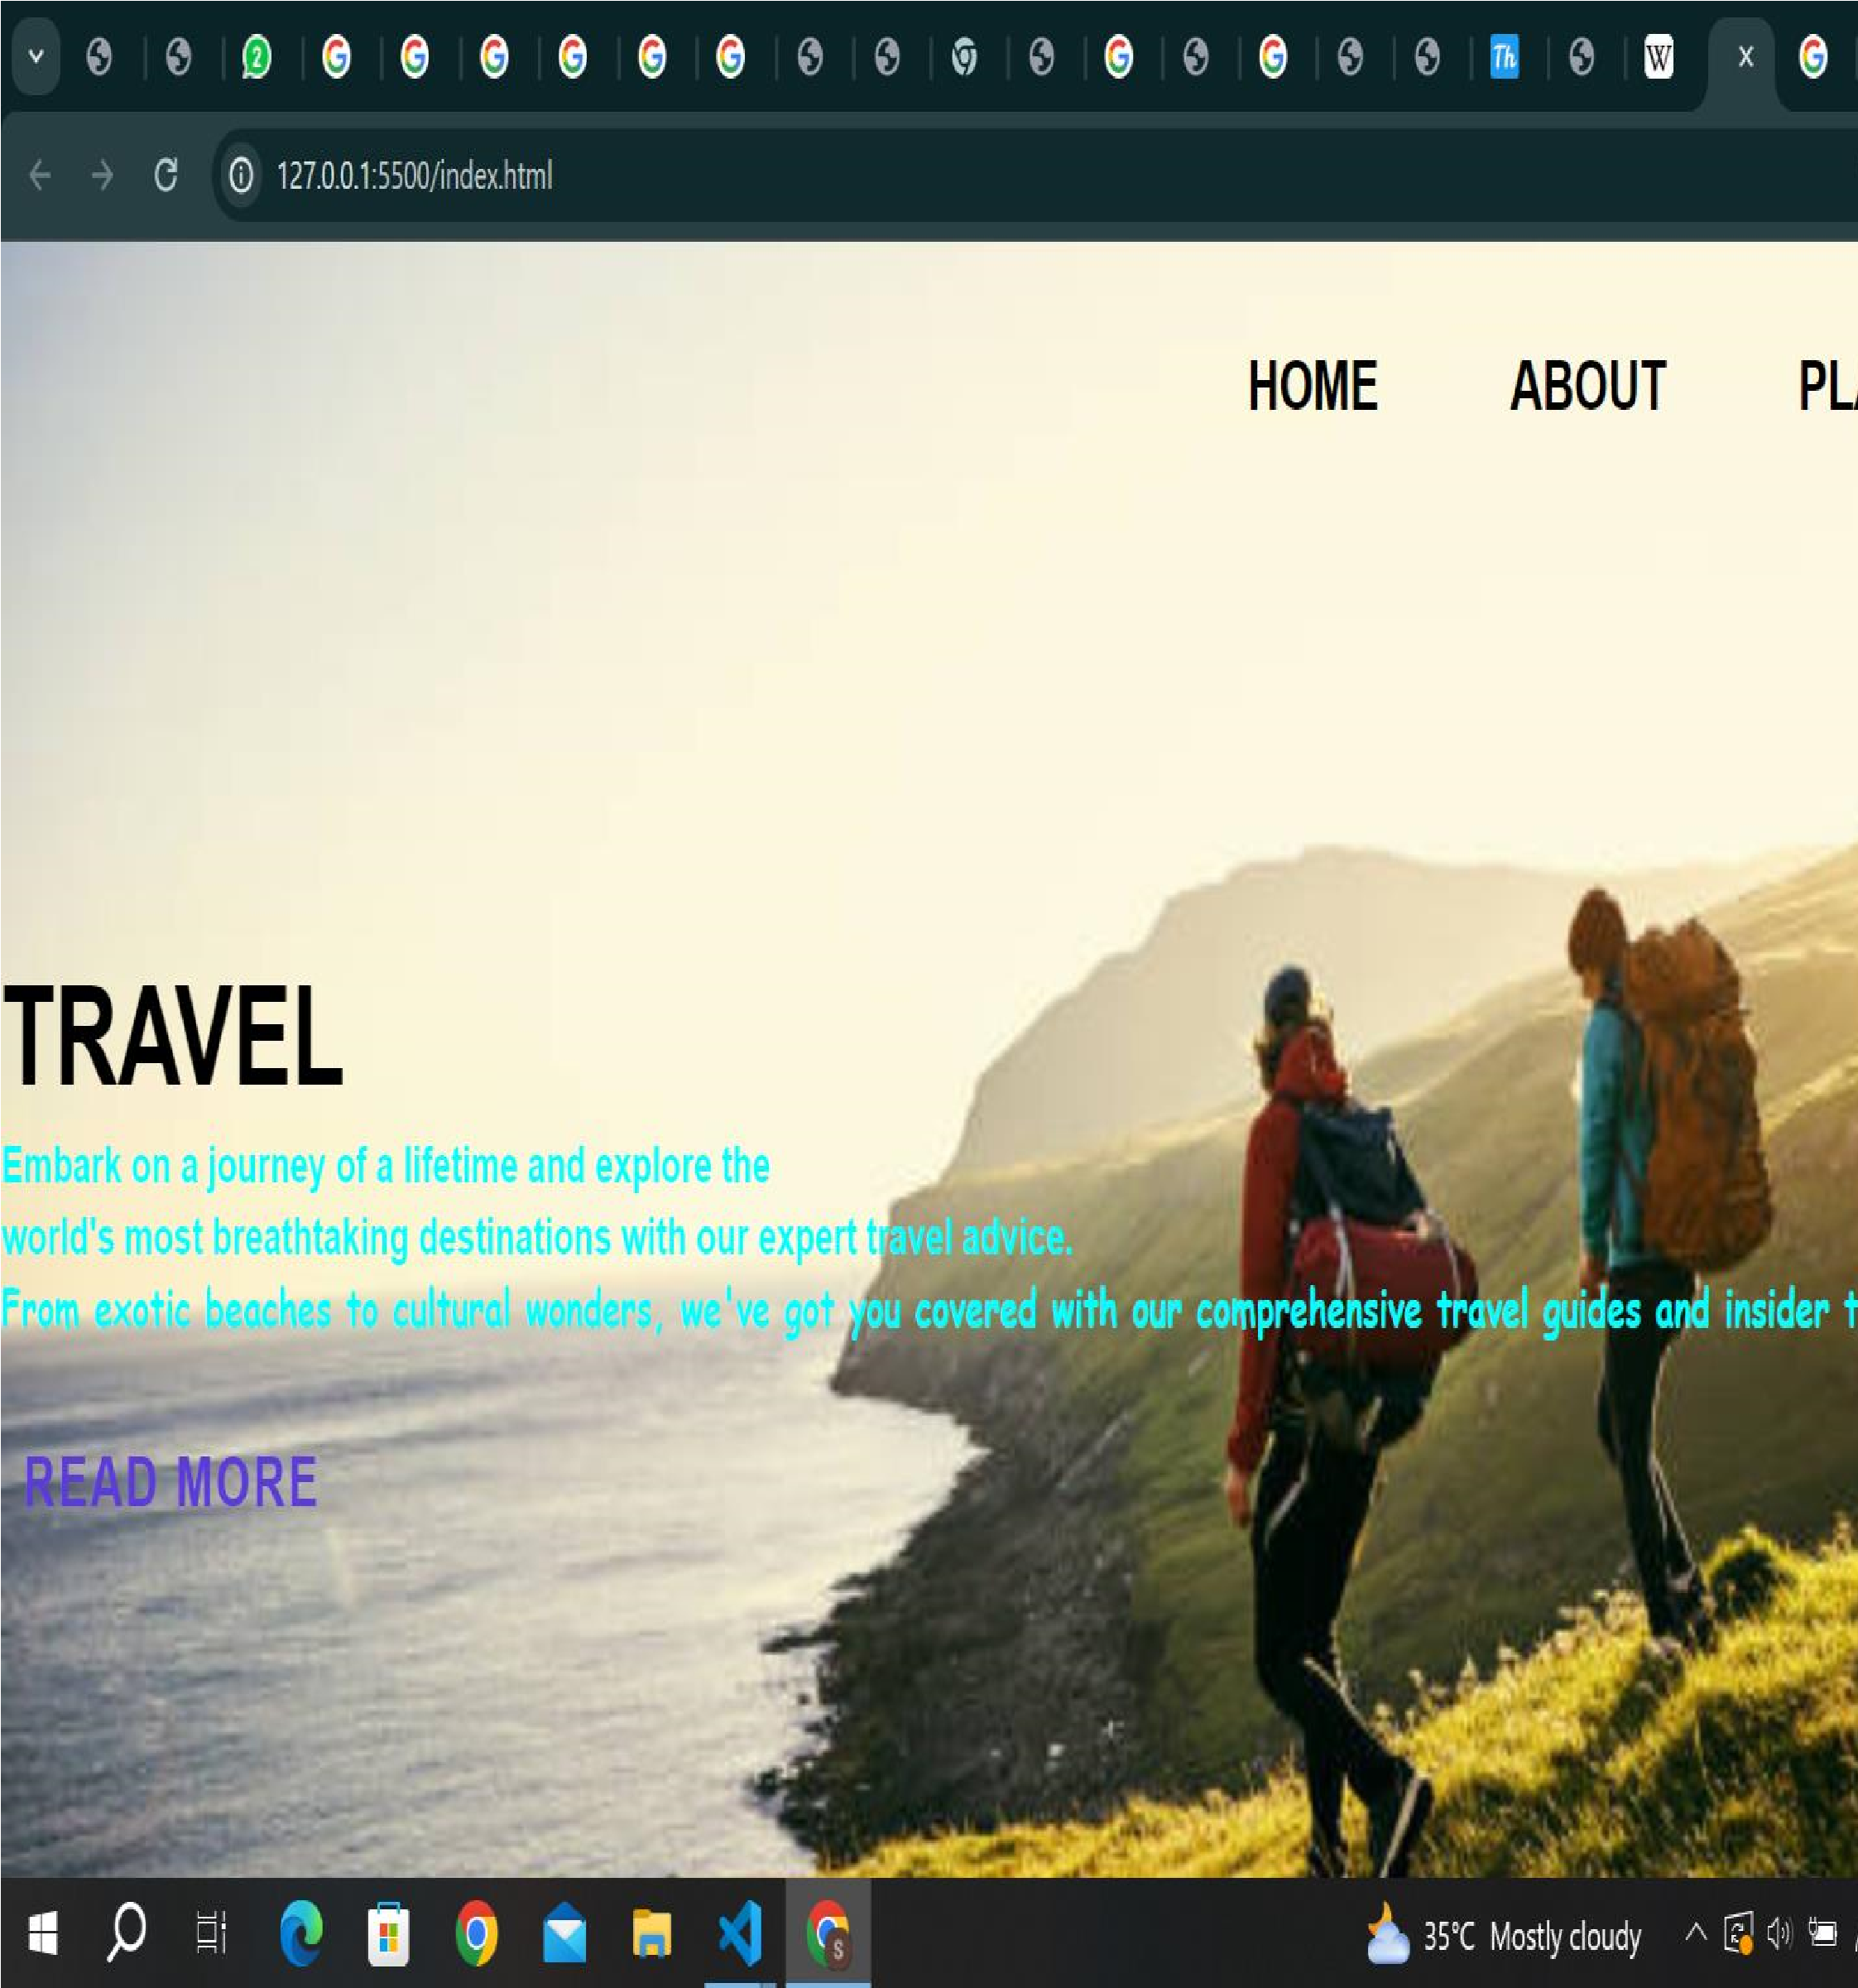.image{ width: 100%; min-height: 100vh; padding: 0px 80px; display: flex; flex-direction: column;

|  |
| --- |
| background-color:white;  }  .image h1{ font-size: 25px; font-weight: 500px; text-transform: uppercase; margin-top: 10px; margin-left: 400px; color: rgb(14, 11, 10); letter-spacing: 0.5px; padding: 8px 2px  }  .image p{ font-size: 13px; text-align: justify;    }  .image h2{ font-size: 15px; color: black;    } |

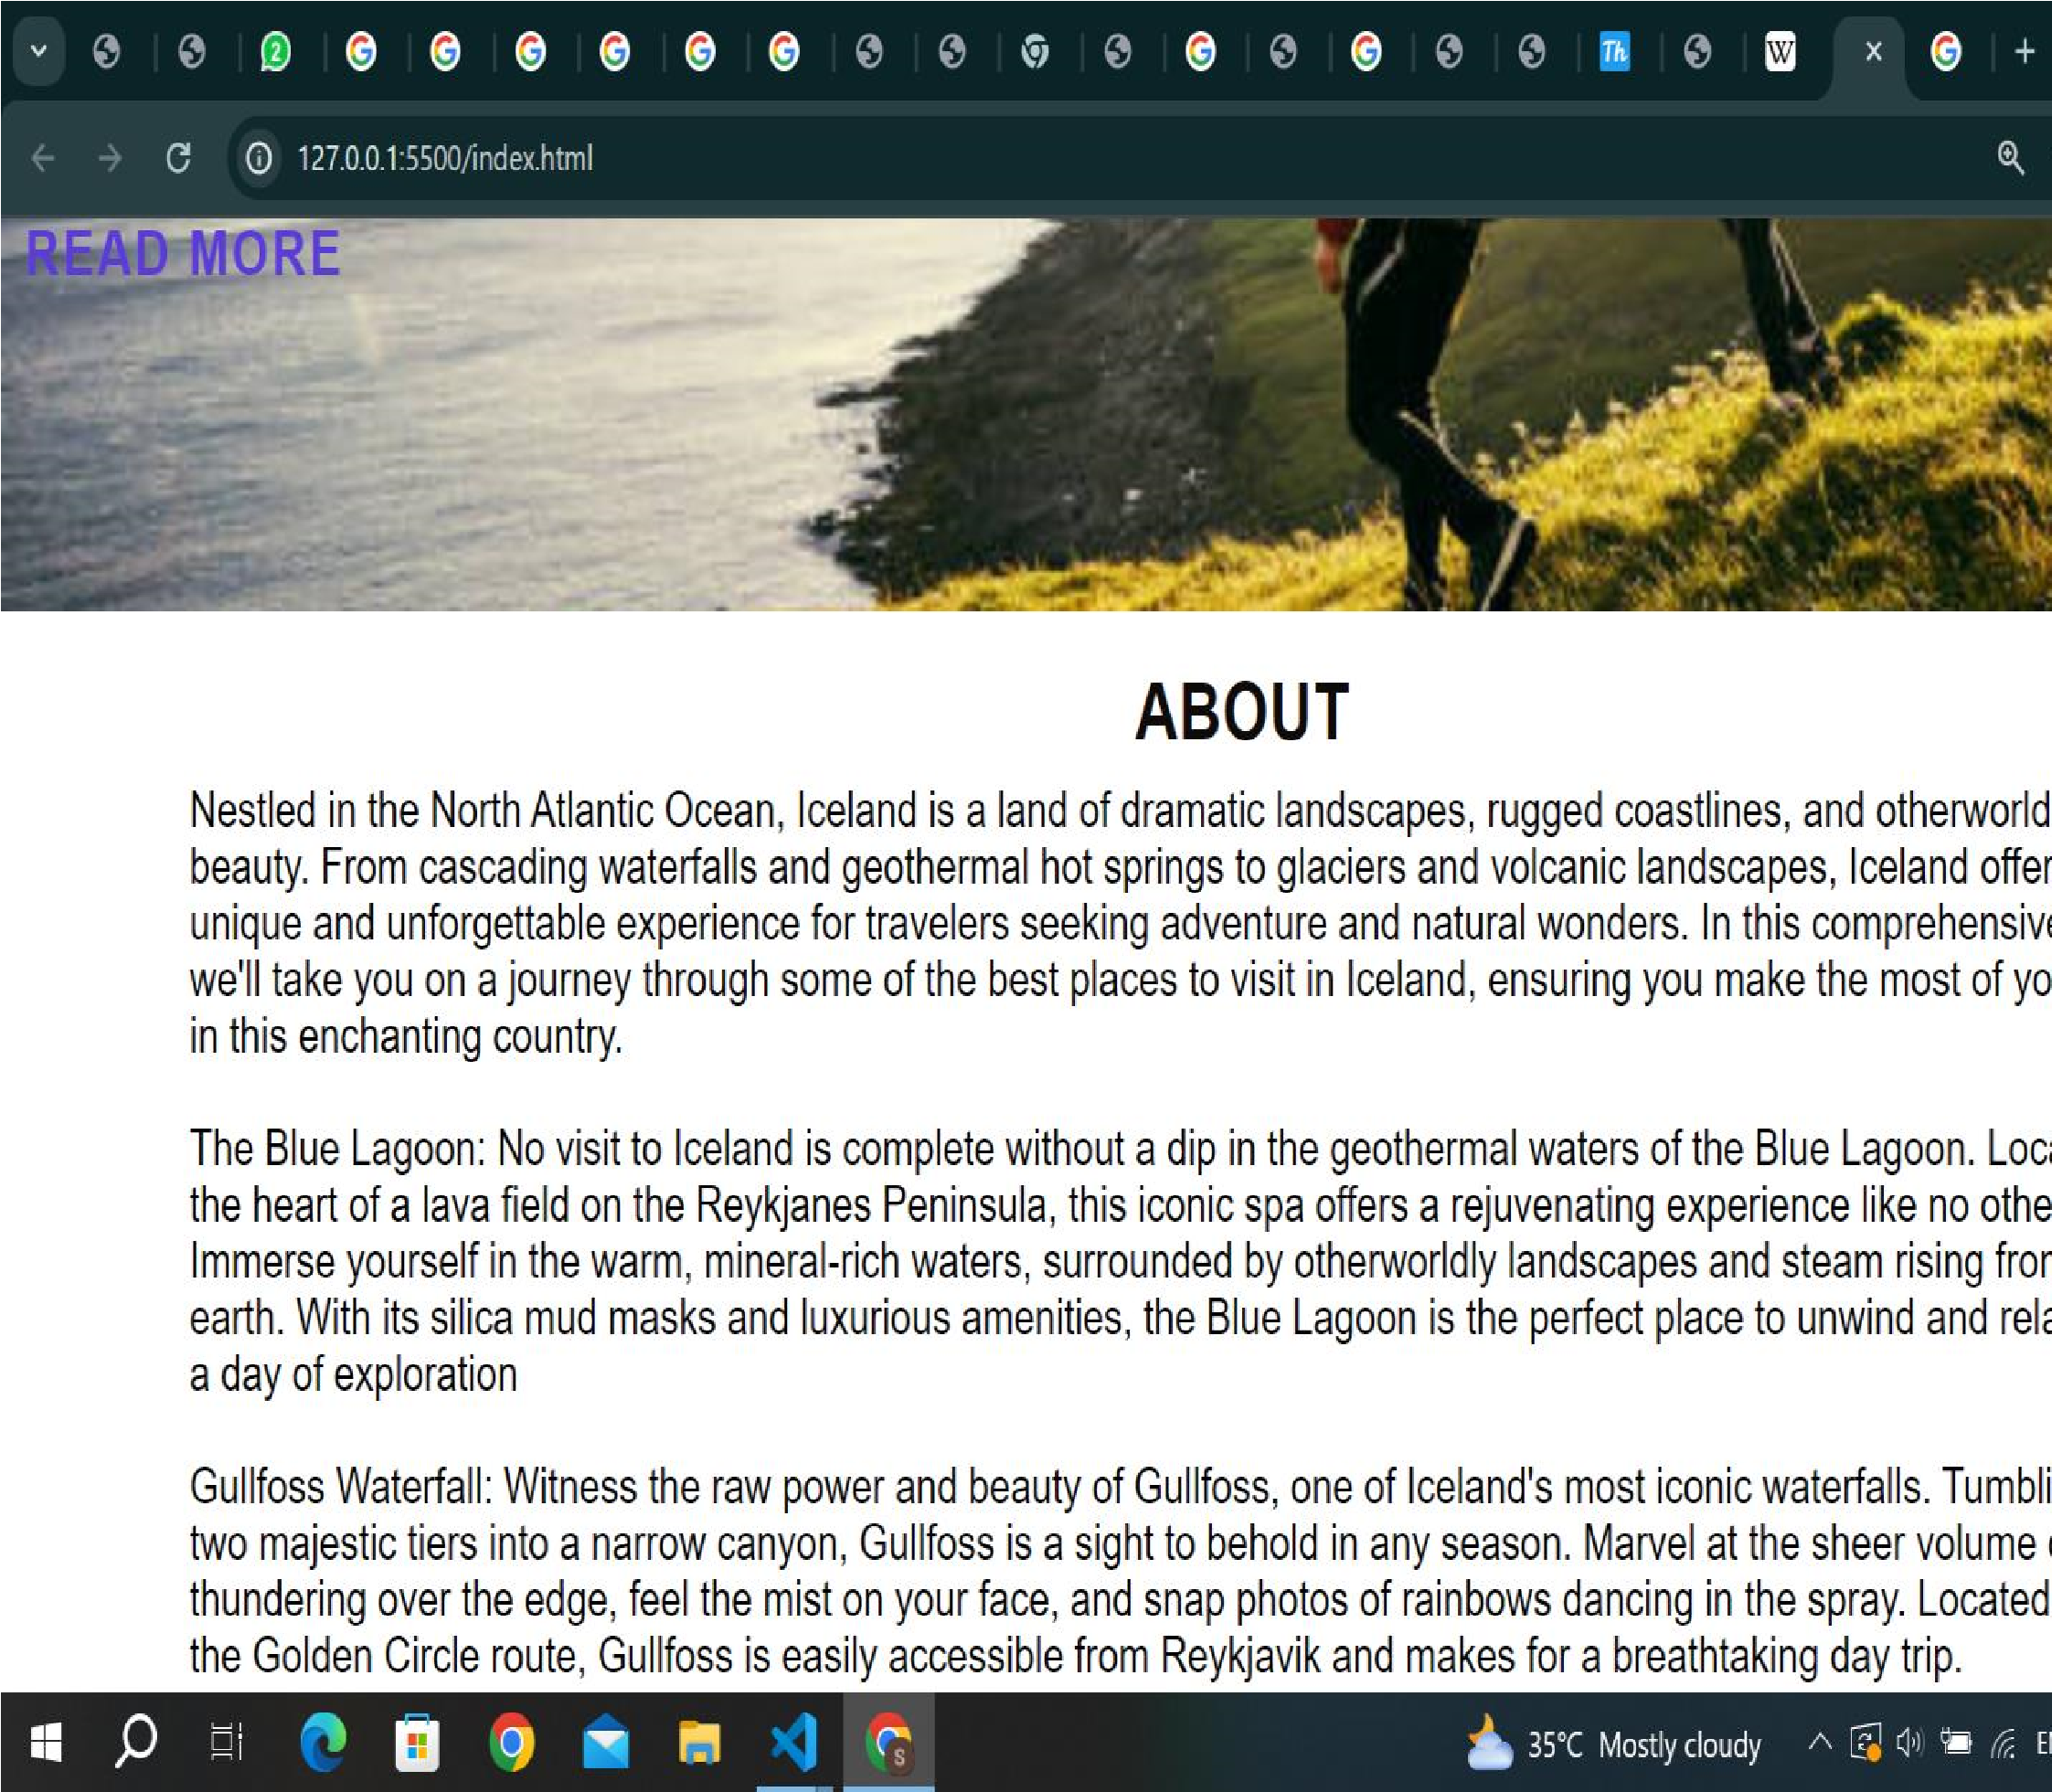.pictures img { display: inline-block; padding: 5px 10px;

}

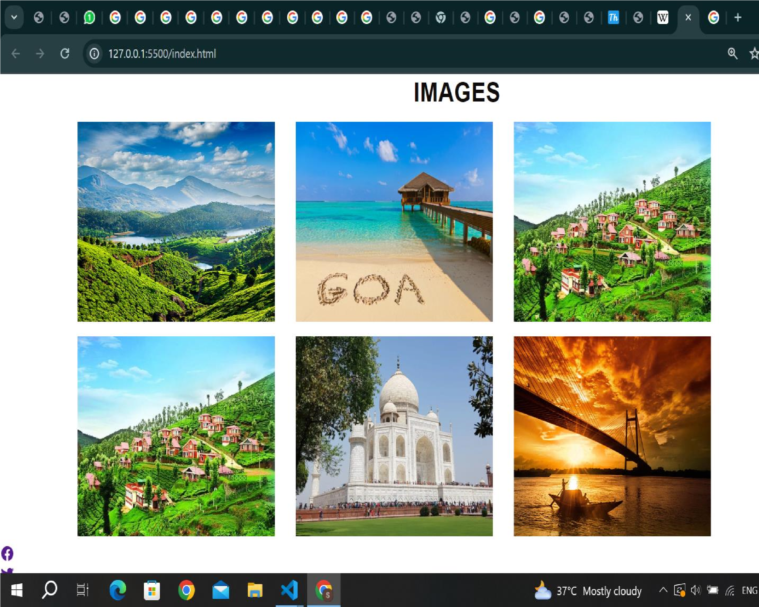

|  |
| --- |
| {  display: flex; flex-direction: column; font-family: Georgia, 'Times New Roman', Times, serif; text-align: center; text-transform: uppercase; padding-top: 30px; background: #272727;  } footer li{ list-style: none; display: inline-block; margin: 10px;  }  .footer-icons a{ background: rgb(246, 236, 233); color: #272727; padding: 10px; border-radius: 100px; display: flex; font-size: 20px;  } |

|  |
| --- |
| .footer-icons a:hover{ color: #ffffff;    }  .footer_menu a{ color: #fff;  text-decoration: none;    }  .footer_menu a:hover{ color:white;  }  .footer-copy{  background-color:rgb(235, 221, 235); color:black; margin-top: 30px; padding: 10px;  }  .courses li{  align-items: center;  } |

